**Java Apache/JFreeCharts CSV Demo & Report – Project 2**

**Anthony D’Alessandro**

**Table of Contents**

Methods……………………………………………………………………………………………1

Plotter…………………………………………………………………………………...…1

Salter………………………………………………………………………………………2

Smoother…………………………………………………………………………………..3

Graph………………………………………………………………………………………4

Small Scale Trial…………………………………………………………………………………..5

Plotter……………………………………………………………………………………...5

Salter………………………………………………………………………………………6

Smoother Run 1…………………………………………………………………………...6

Smoother Run 2…………………………………………………………………………...7

Smoother Run 3…………………………………………………………………………...7

Larger Scale Trial………………………………………………………………………………….8

Plotter……………………………………………………………………………………...8

Salter………………………………………………………………………………………9

Smoother Run 1…………………………………………………………………………...9

Smoother Run 2………………………………………………………………………….10

Smoother Run 3………………………………………………………………………….10

**Methods**

Plotter

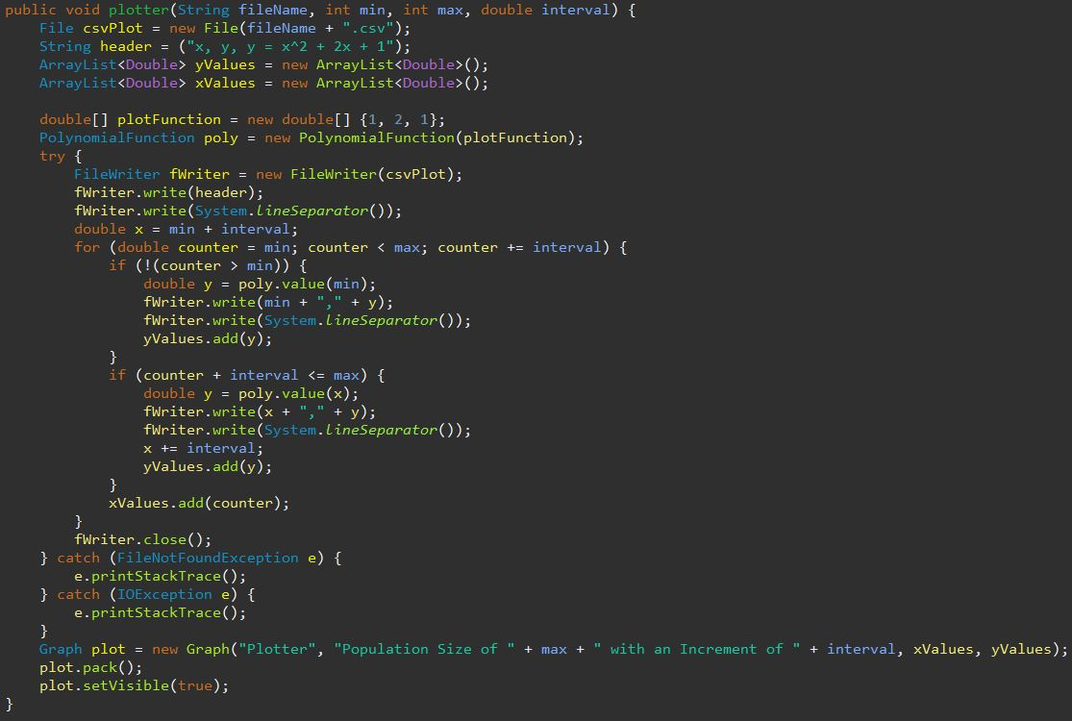

Salter

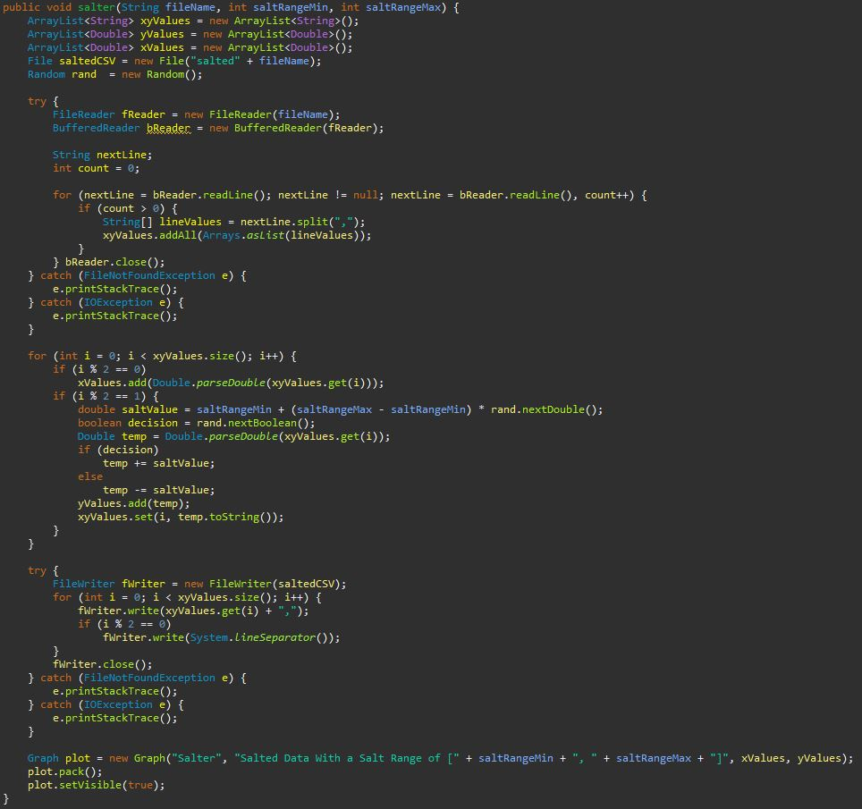

Smoother

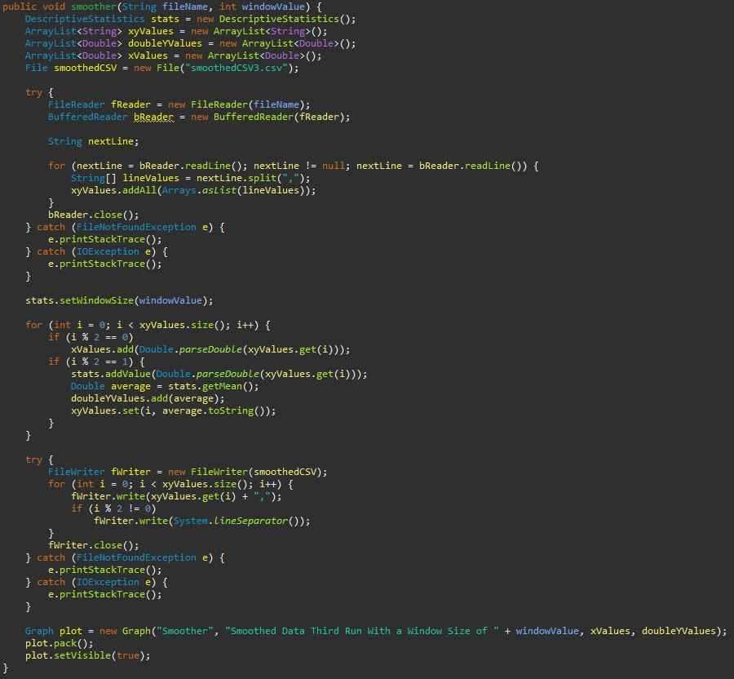

Graph (Class/Method)

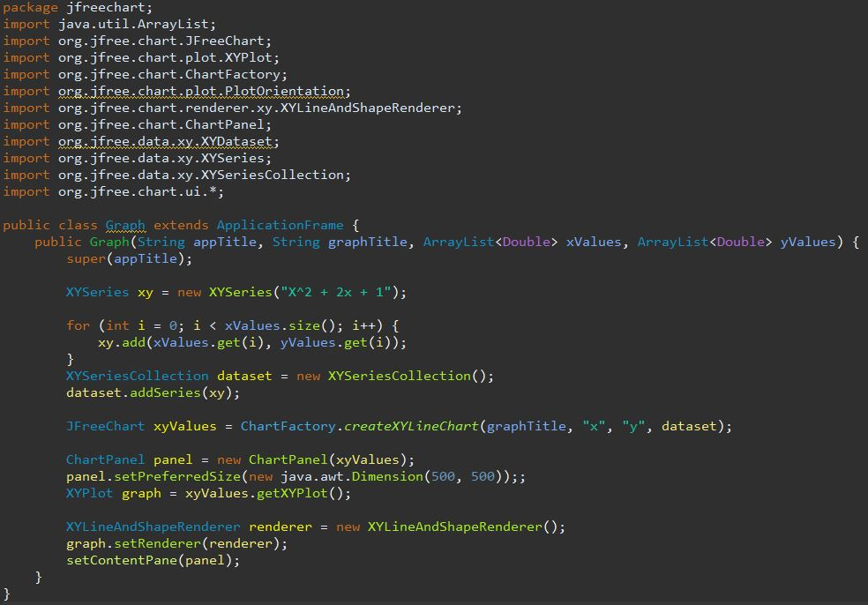

**Small Scale Trial**

Function Used: $x^{2}+2x+1$

Plotter

* Data generated using a population range from [1, 50] with an increment of 0.5



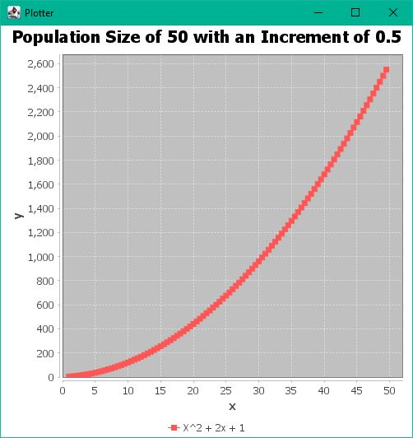

Salter

* Data salted with a salt range from [0, 250]



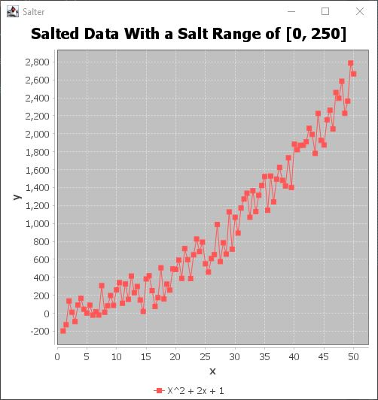

Smoother

* Data smoothed with a window size of 8



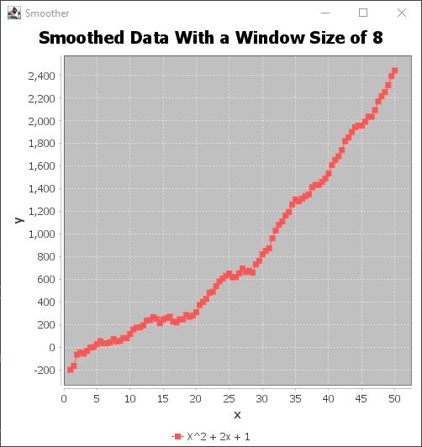

Smoother (Run 2)

* Smoother ran on first set of smoothed data with a window size of 8



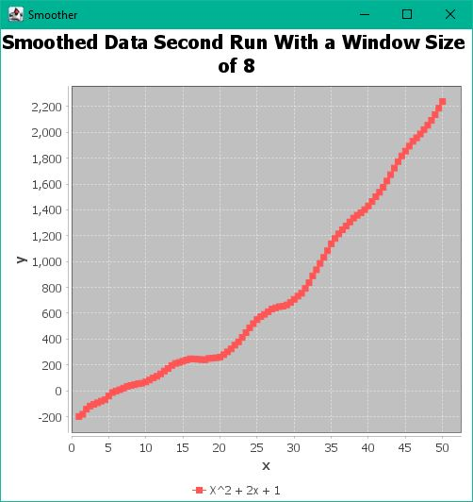

Smoother (Run 3)

* Smoother ran on second set of smoothed data with a window size of 8



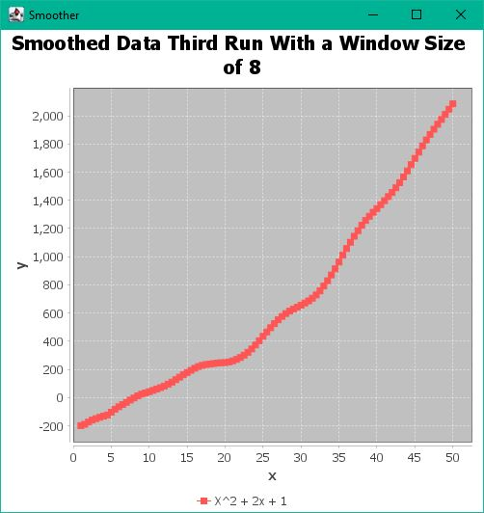

**Larger Scale Trial**

Function Used: $x^{2}+2x+1$

Plotter

* Data generated using a population range from [1, 500] with an increment of 0.5



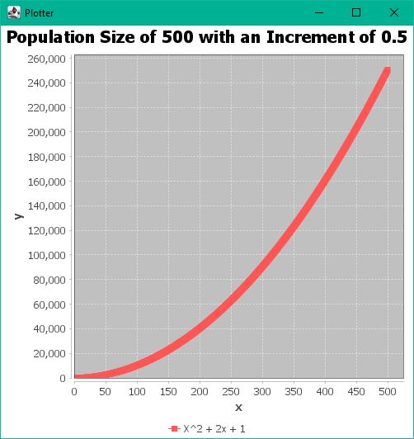

Salter

* Data salted with a salt range from [0, 100000]



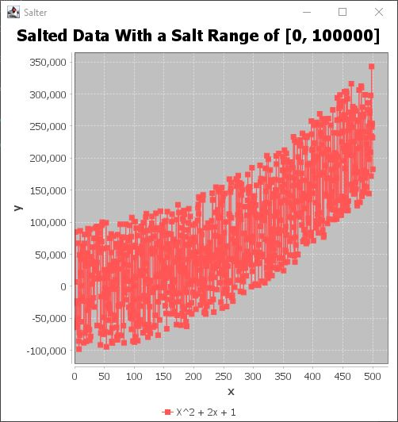

Smoother

* Data smoothed with a window size of 25



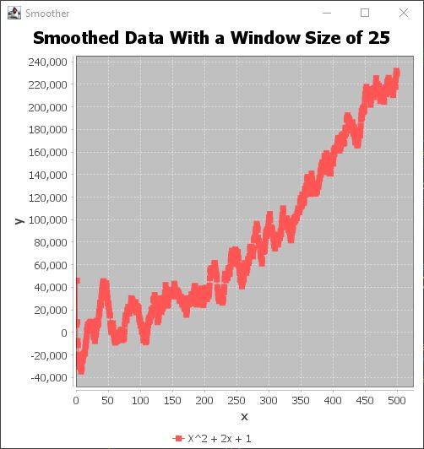

Smoother (Run 2)

* Smoother ran on first set of smoothed data with a window size of 25



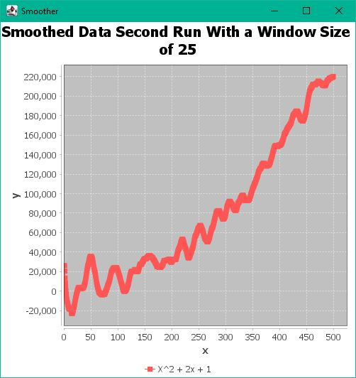

Smoother (Run 3)

* Smoother ran on second set of smoothed data with a window size of 25



